Performance Task

Rocket Engine Regression Analysis Lab

AP Computer Science Principles

October 18, 2017

M. Heinen



**Table of Contents**

# Problem Statement ...……………………………. Page 3

Describe data collection and what you are trying to do.

# Solution Technique ……………………………… Page 3

Describe the development process… how you are going to do it.

# Data Results ………………………………………. Page 4

Describe your findings… describe what you got.

# Conclusions ……………………………………….. Page 5

Describe findings and make recommendations based on your findings.

Appendix A – Clean Copy of the Problem Statement …………….. Page 6

Appendix B – Manipulation of Regression Equation ……..……….. Page 7

# Problem Statement [how data was collected and what is supposed to be done]

Using the (partial) experimental rocket engine data shown in Appendix A, provide answers the following questions:

## Using regression analysis, develop an equation from the data which best describes the velocity at Point B as a function of temperature at Point A.

## Fill in the missing data points using interpolation.

## Extrapolate the temperature required at Point A for the gas velocity at Point B to be 550 m/sec.

## Discuss the potential errors of predicting a temperature to produce a gas velocity of 550 m/sec.

# Solution Technique [how it’s going to be done – the development process]

## MS Excel was used to plot the data points and regression analysis was performed. A scatter plot was created and a logarithmic regression line was selected as best fit. The commuter was commanded to provide the equation of the logarithmic function determine the R2 value.

* 1. The regression equation was then used to calculate (interpolate) the missing data points.
  2. To extrapolate the temperature required to produce a gas velocity of 550 m/s at Point B, the logarithmic equation was solved for the temperature and the velocity of 550 m/s was input as the independent variable thus solving for the temperature.
  3. In Section IV (Conclusions) the potential error(s) of predicting the temperature at Point A to produce a gas velocity of 550 m/s at Point B are explored.

# Data Results [describe your findings – trends, patterns, relationships, etc.]

* 1. Thescatter plot of the data is shown in Figure 1 accompanied by the logarithmic regression line equation and R2 value.



* 1. The regression equation was manipulated (see Appendix B) as follows:

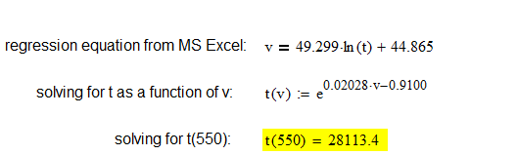

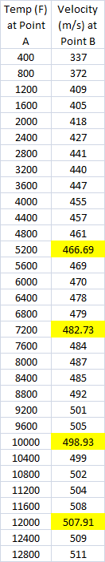

# Conclusions [describe findings – make recommendations]

* 1. The missing (interpolated) are points are shown highlighted in the data set to the right.
  2. The extrapolated temperature to produce a gas velocity at Point B of 550 m/s is 28,113.4 as shown above in Section III.B.
  3. The potential errors associated with predicting the temperature required to produce a 550 m/s velocity at Point B stem from the assumption that the regression equation will remain unchanged. **The stability of this equation is uncertain.**

**Appendix A – Clean copy of the problem Statement**





A typical liquid fueled liquid oxygen-kerosene rocket engine is shown schematically to the right. The exit velocity of the gasses at Point B are primarily a function of the temperature at Point A. Empirical data for the test engine is provided in the table.

Using regression analysis, develop an equation from the data which best describes the velocity at Point B as a function of temperature at Point A.

Fill in the missing data points using interpolation.

Extrapolate the temperature required at Point A for the gas velocity at Point B at be 550 m/sec.

Discuss the potential errors of predicting a temperature to produce a gas velocity of 550 m/sec.

Create a single, professional MS Word document as a solution for this project and e-mail this document as an attachment to mheinen_1@msn.com.

Use the following format for your file:

LastName_FirstInitial-RocketLab

Example: HeinenM-RocketLab.docx

Include all calculations, data, graphs, and include explicit answers.

**Appendix B – Manipulation of the Regression Equation to Solve for t**

