Practice PT Planning Guide - Design a Digital Scene

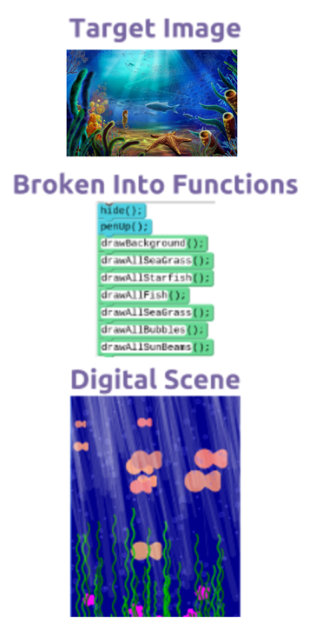
Background
The beginning of our programming unit has focused on how to use Top-Down Design as a strategy for thinking about how to design and write programs. Functions, parameters, and loops have allowed us to break down increasingly complex drawings into logical pieces. Most recently, we combined all three of these programming constructs to design an “Under the Sea” digital scene.

Abstraction: Everyone uses abstraction on a daily basis to effectively manage complexity. In computer science, abstraction is a central problem-solving technique. It is a process, a strategy, and the result of reducing detail to focus on concepts relevant to understanding and solving problems. Top-Down Design is a technique for discovering the levels of abstraction in your problem so that you can effectively write code to solve it.

Collaboration: Top-Down Design also helps by breaking up a problem in a way that lets multiple people collaborate and work on it at the same time. Often programming projects are divided among many programmers. Each person is responsible for programming a portion of the final product. In order to do this, everyone on the team must understand the overall plan at a high level, but each person only needs to worry about the nitty gritty details of the portion they are responsible for.

Project: Collaborate to Design a Digital Scene
For this project, you will be working with a group to design your own digital scene. Your group can choose any kind of digital scene to create. You have already seen how the “Under the Sea” scene was created, but here are some guidelines to consider when picking your own:

Your scene should...
- Be of interest to every member of the group
- Have several components that allow it to be broken into logical chunks
- Have repeated elements that will allow you to use loops and potentially random values
- Have elements that would benefit from creating a function with a parameter (same figure but different size / color / dimensions, etc.)

Each member of your group will write the code to complete a portion or portions of the scene. Then bring all the code together to compose the final image! You will submit your own project and written reflection, but it must use code written by your teammates.

General Process
- Get together with your group (recommended groups of 3 or 4 people)
- Do Group Project Planning (see below)
  - Brainstorm ideas, break the problem down, delegate tasks
- Do your individual programming and share with teammates
  - Program your portion of the project
  - Share your code with teammates, and incorporate others’ code into your project
- Complete your digital scene, write responses to reflection questions, and submit
  - See: Practice PT Project Overview and Rubric - Design a Digital Scene
  - Submission includes final program and completed reflections questions

Group Project Planning
Below we have laid out a process for your group to brainstorm, plan, and eventually create your Digital Scene project. Go through each step together. The outcome of the process will be a project plan (see next two pages) that indicates what you’re trying to create and who is doing what. Get started and have fun.

Understand the problem & timeline |  | Identify the problem to solve. It may sound obvious, but it’s hard to solve a problem if you don’t deeply understand it.  - Review the steps of the process for completing this project (see above and below)  - Review Practice PT Project Overview and Rubric - Design a Digital Scene make sure you understand what is required of you and your teammates.  - Make sure you also understand the time constraints. There’s always too much to do and too little time! This will help you prioritize work later.
Brainstorm |  | What kind of digital scene will you create? Make it rain with ideas! Whether you’re in a group or on your own, take the time to generate lots of different ideas for your digital scene  - Put a time limit on how long you will brainstorm  - No criticism of ideas, only building up on ideas  Once you have decided on what your scene will be, complete the Project Description below. It must contain a brief description and at least a rough sketch of what you are trying to create.
Break it down |  | Use Top-Down Design to identify the major components you will wish to include in your image. At this point you only need to break down the image at a high level.  - Decide as a group what high-level functions you will need.  - For example, in the Under the Sea project, the high-level functions for each component were things like: drawAllFish(), drawAllSeagrass(), drawAllBubbles(), etc. These high-level functions are all you need to think about at this point.
Assign tasks & prioritize |  | Each of the high-level functions you identified will be programmed by one member of the group.  - Assign the high-level functions you identified evenly among your group.  - If people have more than one thing to do, you should prioritize: what can be cut if you run out of time or if there is an unanticipated bump in the road?  - Once you have assigned functions, each group member can begin working individually to program the components they have been assigned.  Complete the Project Component Table below; this is where you will declare what functions you will write and who will do what.

Name(s)_____________________________________________________ Period _______ Date ______________

Project Description
Once you have chosen your topic, write a brief description of it below and include either a sketch or digital image that shows what you are aiming to draw. It’s fine if your image includes more components or detail than you will be including in your digital scene. You can also have more than one representative image.

Scene Title:

Group Members:

Short Description:

Example Sketch / Digital Image:

Name(s)_____________________________________________________ Period _______ Date ______________

Project Component Table
With your group, identify the major components you would like to include in your digital scene. For each component, provide a descriptive and meaningful name for the function that will draw that component, provide a short description of what the function does, and assign the function to a member of the team.
You do not have to fill this table, but you can, and you can add more rows if necessary. This is just a template.

Component | Function Name | Description of Function Behavior | Group Member

