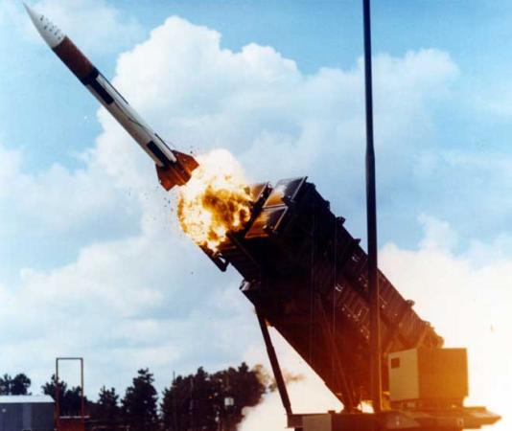
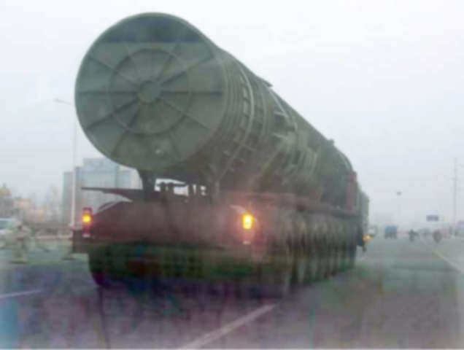
On May 1, 2019 China launches 18 each DF-31A intercontinental ballistic missiles (ICBMs) at the west coast of the USA. Each DF-31A warhead carries 3 H-bombs each of about 250 KT (each bomb is 17 times more powerful than was dropped on Japan at the end of WWII).
The USA has developed Patriot missiles to intercept incoming ICBMs. As a Patriot missile battery officer assigned to protect San Diego, your battery detects an incoming Chinese war head aimed at San Diego (where you are located). You mission is to launch your Patriot missile to destroy the incoming Chinese warhead.
Figure 1 - Chinese DF-31A ICBM
Figure 2 – US Patriot Missile
Your radar provides the following information about the incoming warhead at time of detection (t = 0 seconds): vertical height = 390,000 feet (about 73 miles) with an incoming vertical velocity = -3107 feet/second. You know the following information about your Patriot missiles located at sea level: initial upwards velocity of 7,115 ft/second. You also know that the Chinese missile is typically designed to explode at 3 miles (about 16,000 feet) above the ground.
Armed with this information and using quadratic mathematics and MS Excel, answer (at a minimum) the following questions:
- If your missiles require a minimum of 20 seconds to launch from t = 0, calculate the time and altitude of earliest interception.

- What is the latest time (as measured from t = 0) that you can launch the Patriots and still expect to intercept the missile before it explodes destroying Dan Diego, killing 5 million Americans along with you in the process?

Prepare a word processed document with supporting graphs, documentation, spreadsheets, and calculations explicitly identifying the answers to these questions.
E-mail this document as an attachment to: mheinen_1@msn.com NLT midnight November 29, 2015.
Label the document file as follows: Your_last_name-ICBM.docx

