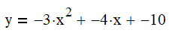
- Accurately graph the function:

a = ______ b = _______ c = ___________

- Happy or frowny face? ________________

- X_{sym} = _______________________

- Y axis intercept = __________________

- Vertex = (________, __________)

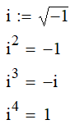
- Solve for the roots (zeros) using the quadratic formula where: $x=\frac{-b±\sqrt{b^{2}-4ac}}{2a}$

- Solve for the roots (zeros) by completing the square:

- Solve for the roots using factoring and the zero-product property of multiplication (if the expression can be factored!).

- Put the equation into vertex form.
Remember: Vertex form:

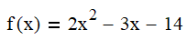
- What is the discriminant for the quadratic equation:

What does this mean?

- Given the two equations:

Find where the equations intersect.

- Given the following two quadratic inequalities, graph each inequalities and shade in the area where coordinate pairs solve both quadratic inequalities. Scale the graph as appropriate.



