Three (basic) operations permitted in linear algebra:

1. You may multiply any row by any non-zero constant.
2. You may swap any row with any other row.
3. You may add a linear combination of ANY row to ANY other row.

- Solve the following equations using Gaussian Reduction. You must show all work.
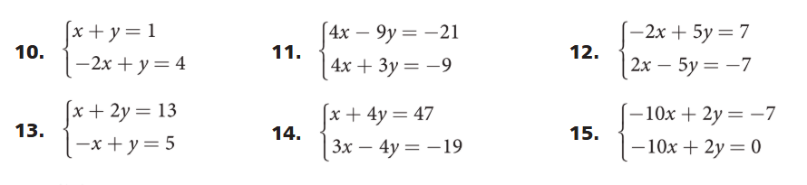
- To assist in the solutions, you may download Mr. Heinen’s Gaussian Reduction 2x2 Solver (Excel format) from his website: http://www.markeredwards.com/Algebra2/Alg2.html to confirm your answers.

EXAMPLE TO SOLVE 2X + 4Y = 12
-3X +2Y = - 6

