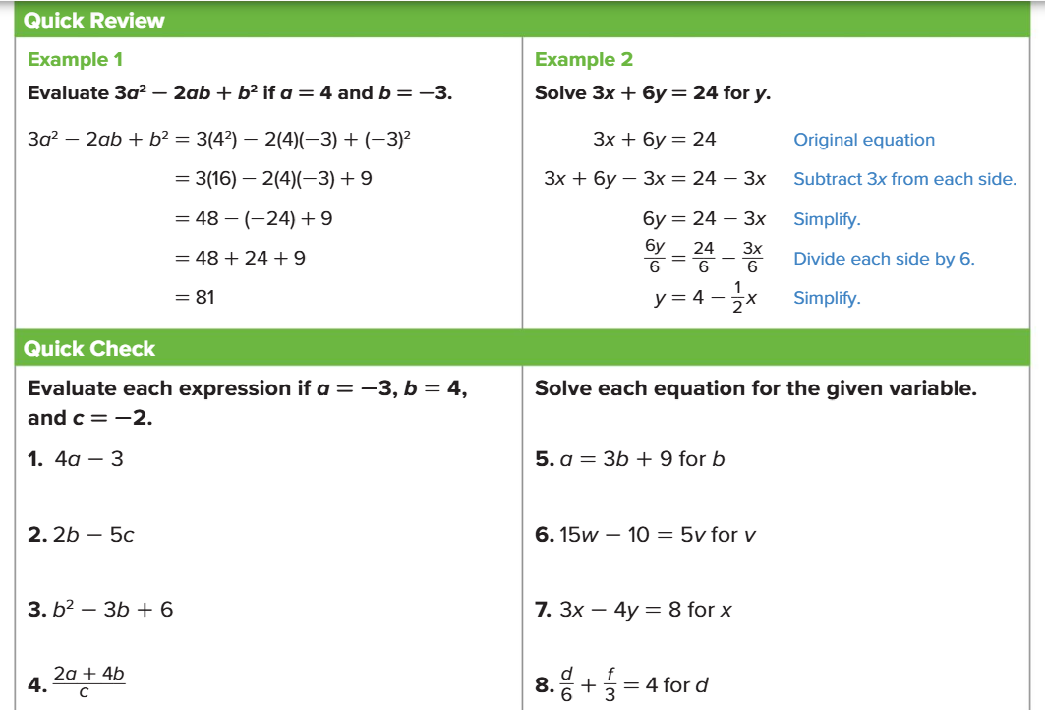

**Example 3: Given the two lines (linear functions) shown to the right, provide the (x, y) coordinate of their intersection (If any).**

10 = 2x - 4y

y = 3x + 9

**Answer = ( ______ , ______ )**

