--------------------------- SHOW ALL WORK ---------------------------------
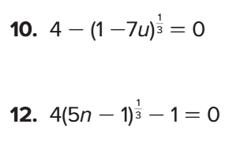
Problem 1 – Solve for u. Show all work and check for extraneous roots.

Problem 2 – Solve for n. Show all work and check for extraneous roots.

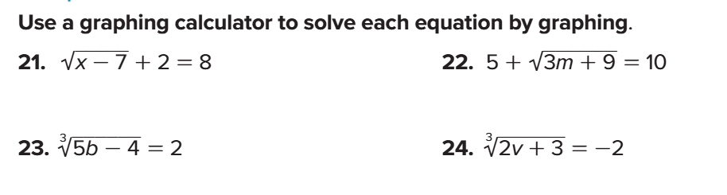
Problem 3 – Solve for v. Show all work and check for extraneous roots.

Problem 4 – Solve for m. Show all work and check for extraneous roots.

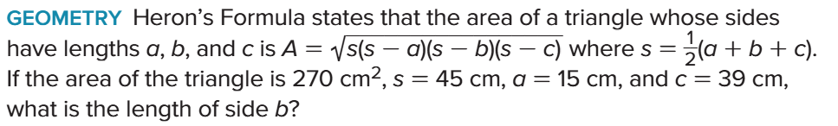
Problem 5 – SHOW ALL WORK.

Problem 6 – Solve for x. SHOW ALL WORK. Problem 7 – Solve for x. SHOW ALL WORK.
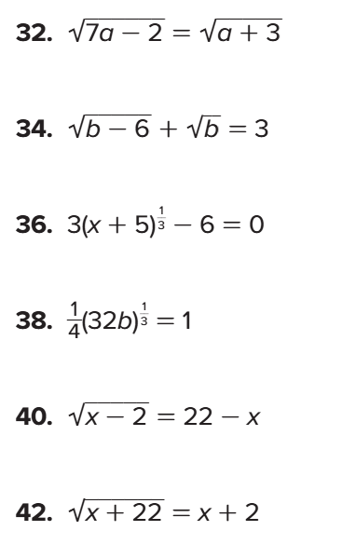

Problem 8 – Solve for x. SHOW ALL WORK. Problem 9 – Solve for x. SHOW ALL WORK.

