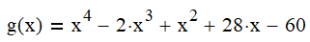
- Problem 1 (Show ALL Work)
- Showing all work, identify the number of possible positive and negative real roots using Descartes’ Rule of Signs.
- Solve and identify all roots showing all work. Double underline all answers.
- Accurately graph the equation and identify all real roots, axis intercepts, and other key features of the curve. Scale the graphs’ axes as necessary to create an accurate graph.


- Problem 2
- Showing all work, identify the number of possible positive and negative real roots using Descartes’ Rule of Signs.
- Solve and identify all roots showing all work. Double underline all answers.
- Accurately graph the equation and identify all real roots, axis intercepts, and other key features of the curve. Scale the graphs’ axes as necessary to create an accurate graph.

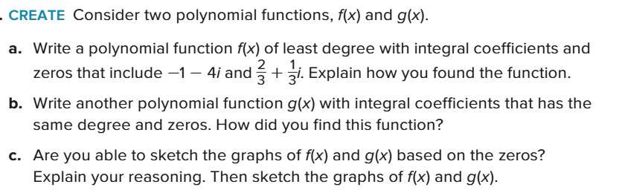
- Problem 3

- Problem 4 – Use of the problem solving steps is suggested. 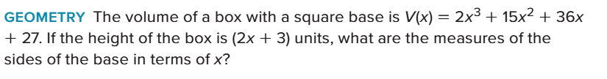

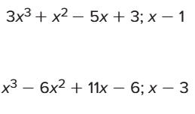
- Problem 5 – Solve for all roots of the polynomials shown:

- Problem 6: An aircraft’s flight altitude (in meters) is given by function a(x) were a(x) is the aircraft’s altitude as a function of the distance flown (x in km).
An intercepting missile’s altitude is given by m(x) shown having the same unit dimensions.

Create a root function, and solve the root function for its roots to calculate the distance x when both craft will have THE SAME ALTITUDE.
